How to apply for the Graduate Safety Practitioner (GSP) designation

Once you have graduated from a Qualified Academic Program (QAP) you can apply for the Graduate Safety Practitioner (GSP) designation.

The benefits of holding the GSP designation are:
- Recognition for being in a path toward the CSP certification.
- Recognition for the level of preparation for professional safety practice.
- Recognition of the level of knowledge of the fundamentals of safety.
- There is no GSP application fee.
- A waiver of the ASP examination.
- A certificate awarding the GSP designation.

- Create an account on the BCSP website. Go to www.bcsp.org and click on “My Profile” on the top right of the page. On the BCSP My Profile page, click “New Customer? Click here.”

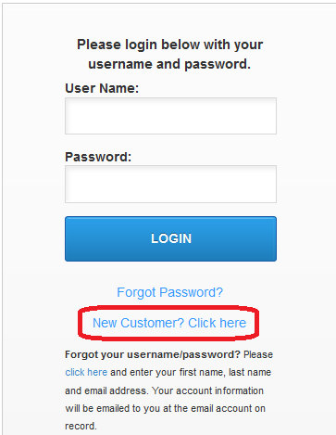

- Once you have created an account, log in. On the main menu, click “Apply for Certification.”

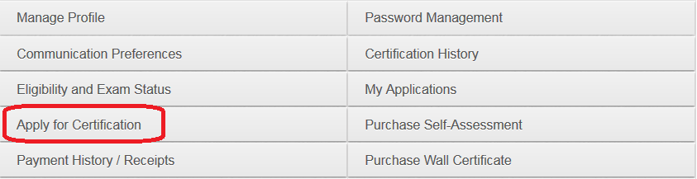

- Click on “Apply for GSP Certification.”

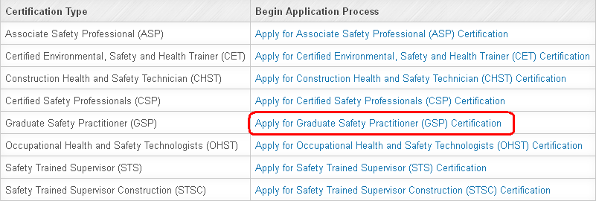

- Complete the application and submit.

- To check on the status of your application, or if you start but do not complete/submit the application, in the My Profile main menu options click “My Applications.”

- Request your university send BCSP an official transcript. It will take approximately a month for your school to enter your degree into the registrar, so wait a little bit after graduation to ensure your transcript shows degree earned and date conferred.

- Once your GSP application is submitted and your official transcript is received, your GSP designation will be awarded. You will receive an email confirmation as well as a mailed packet with a congratulations letter, wall certificate, and instructions to go into your account and pay your pro-rated Annual Renewal Fee.

- Once you have four years of professional level safety experience you can submit your CSP application.

