The electric bacteria of Chesapeake Bay

Sairah Y Malkin¹, Pinky Liau ¹, Carol Kim ¹, Kalev Hantsoo ², Maya Gomes ², Bongkeun Song ³

¹ Horn Point Laboratory, U. of Maryland Center for Environmental Science (UMCES), Cambridge, MD, USA
² Department of Earth and Planetary Sciences, Johns Hopkins University, Baltimore, MD, USA
³ Virginia Institute of Marine Science (VIMS), College of William and Mary, Gloucester Point, VA, USA

Cable bacteria are long filamentous bacteria that couple spatially separated electron donors and acceptors across centimeter-scale distances in aquatic sediments. Comprising the candidate genera Electrothrix and Electronema (Deltaproteobacteria), cable bacteria are capable of so-called electrogenic sulfur oxidation (e-SOX) in sediments, pairing oxidation sulfur oxidation from reducing depths to the reduction of oxygen or nitrate near the sediment surface. Accumulating evidence from diverse coastal marine systems is revealing that cable bacteria activity exerts a powerful control on sediment geochemistry, with profound consequences for geochemical cycling, at local- and potentially ecosystem-scales. For the past couple of years, we have been investigating the ecology of cable bacteria – defining their niche and biogeochemical role in Chesapeake Bay – with the aim of better constraining their quantitative biogeochemical function at the system scale. Year-round field sampling reveals cable bacteria are quantitatively important in winter and spring in the main stem of the Bay, which experiences seasonal anoxia, and are particularly responsive to sinking diatom phytodetritus in the spring. In this seminar, I will talk about the distribution and ecology of these “electric bacteria” and discuss some of the implications for geochemical cycling.

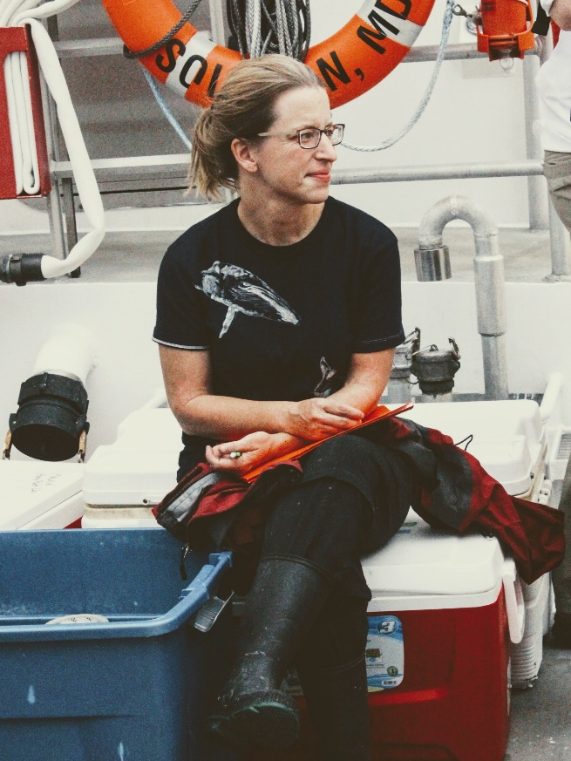

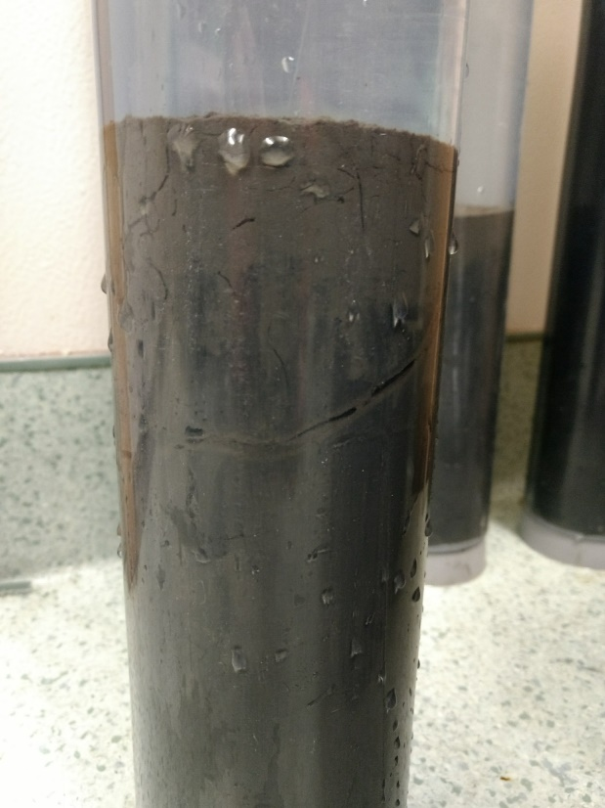
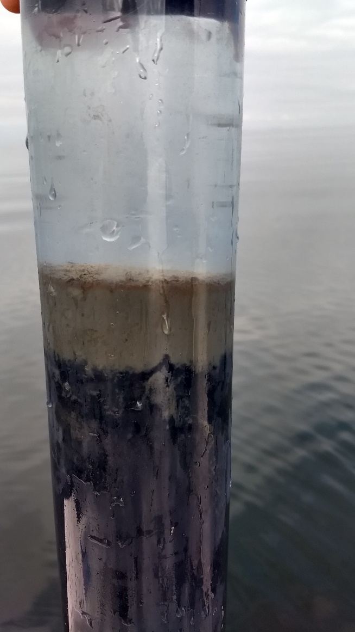
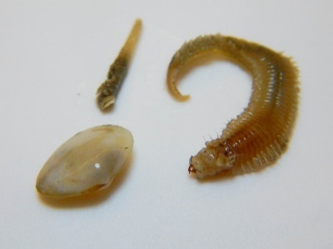
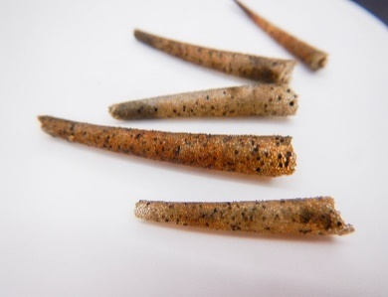
West
Central

