Time to plan for spring!
Plant dormancy, growth and everything in between

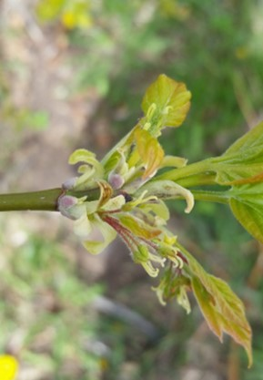
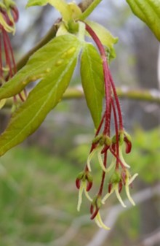
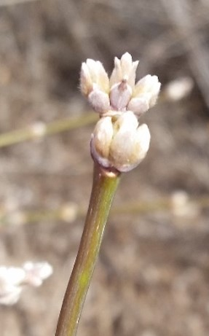
Jessica A. Savage, University of Minnesota – Duluth

The preparation of woody plants for spring begins in the late summer even before we see signs of leaf color change. New buds grow, dormancy is initiated and the last pieces of the vascular system are prepped for spring. In a place like Duluth, which has a short growing season, it is especially important that plants are able to start growing quickly once it warms. However, our climate is changing and becoming more variable. Sometimes we have “false springs” when it warms and then gets cold again. Other times, we have late frosts that delay plants from initiating growth. Are plants able to adjust to these changes? To answer this question, we need to know what factors limit plant phenology (the timing of life cycle events like leaf out and flowering). Our recent work has examined the factors that limit when plants can move the resources necessary for growth. Our work focuses on the plant vascular system because it is the main pathway of transport for sugars and water. We have found that across species, there appears to be a strong connection between the part of the vascular system that transports water (xylem) and the timing of leaf out. We have also discovered that the timing of flowering is tied to how many resources are invested in flowers before the winter begins. We are currently extending our work into the autumn and winter and considering the importance of seasonal changes in plant freezing tolerance and resource storage. In the end, we will not be able to fully understand and predict how plants will change in response to the climate until we know how seasonal changes in plant physiology impact their phenology. Plants are always preparing for spring but whether they will always be ready, waits to be determined.

