MN DNR Deer Check Station Opportunity
The Minnesota Department of Natural Resources is recruiting students to help with chronic wasting disease (CWD) surveillance throughout Minnesota during the 2021 firearm deer season.
- Dates: Saturday/Sunday; Nov 6-7
- Station times: 9am-7pm, Saturday and Sunday; Students must commit to working the entire weekend
  - Potential positions (n=22) available in Hinckley, Mora, Pine City, Sandstone, St. Croix State Park
- To be eligible, 1 hour mandatory training is required (date/time TBD).
  - It will be during the week in the evening, likely Zoom or Microsoft Teams.

- Pay: $13/hour.
- Meal per-diem: $25/day.
- Hotel reimbursement (up to $80/night) is available for students who work >30 miles from their home campus
- Mileage reimbursement: $0.56/mile

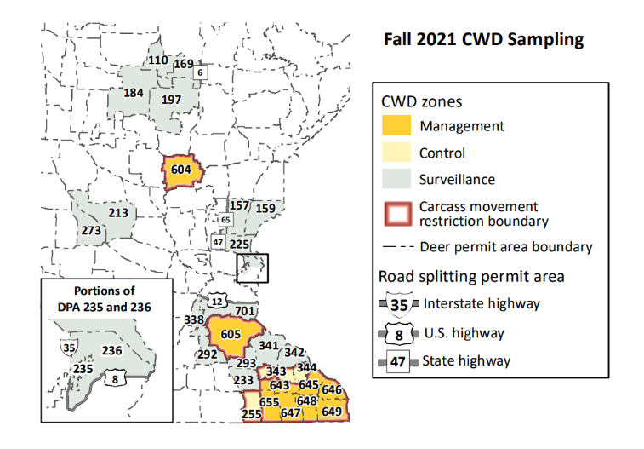
This is a great opportunity to get field experience and work with DNR staff on an important wildlife management issue in the field. Training is required and slots are limited. Please visit https://forms.office.com/g/N36xZyxKLe to get on the training list. You will be contacted once the training session has been set up.
All students must be enrolled in minimum 6 credits

All students need to sign up for payroll in advance of work.
- International students need to be prepared for extra paperwork
- Graduate students on an assistantship (non-med/vet school) cannot get an hourly wage, but they will get all other reimbursements
If you are already employed on campus, please keep in mind that you cannot exceed 40 hours during this time period. Please make sure your supervisor knows that these hours will count toward your paycheck.

