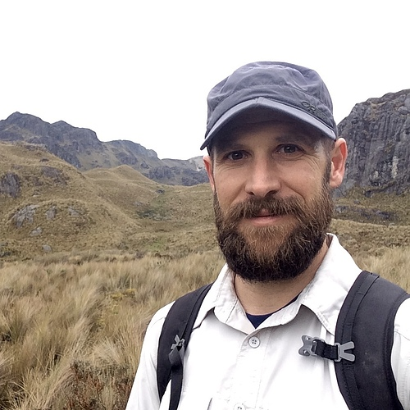

Reimagining restoration: grasslands under global change

Grasslands of North America are one of the most threatened ecosystems on Earth, and future grassland management will require us to confront the reality of global environmental changes. Climate change, nutrient deposition, and altered species assemblages are all currently impacting grassland biodiversity and ecosystem function, creating unprecedented challenges in managing these novel ecosystems. Yet, the goal of grassland restoration is often to return these systems to their perceived historic state, with little consideration of the tradeoffs in such an approach. I will use two ecological case studies, California serpentine grasslands and Minnesota tallgrass prairie, to consider the future of grassland management and restoration. Additionally, reimagining ecosystem management will only be successful if we incorporate diverse perspectives into the practice of conservation. To this end, I will discuss my involvement in efforts to increase engagement of underrepresented groups in the field of conservation science.

